**Module 1 Activity 1: Installation of Tools**

Mohiddeen Vilak Mohammad

Department of Information Technology, Arizona State University

IFT 554: Middleware Programming & Database Security

Dinesh Sthapit

January 21, 2023

**Figure 1:**

*Screenshot of VS Code*

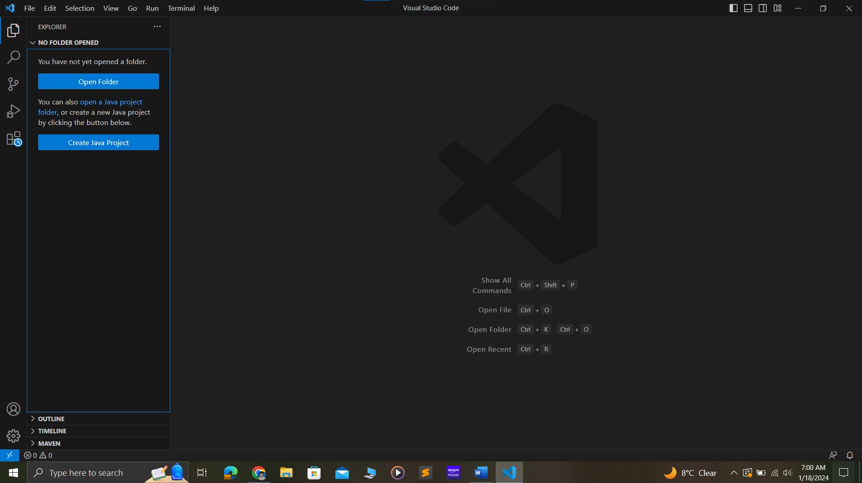

**Figure 2:**

*Screenshot showing node running on pc*

**Figure 3:**

*Screenshot showing npm running on pc*

